
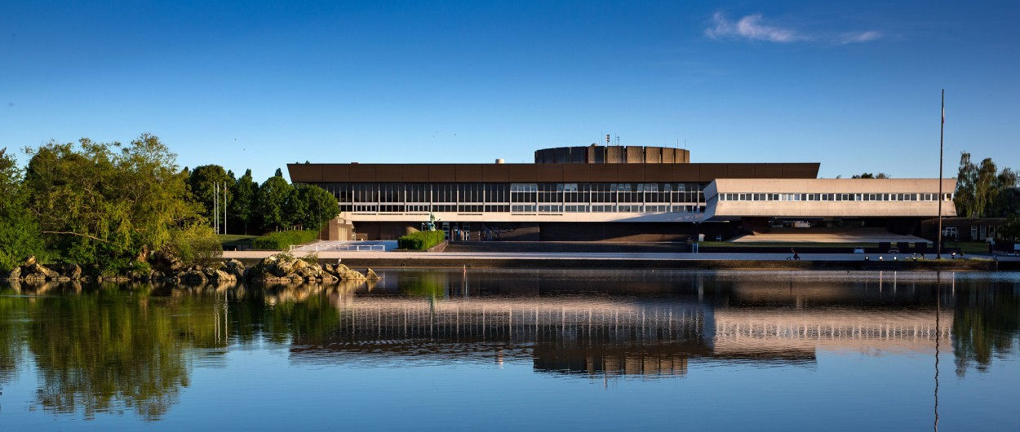
E-mail : visitingprof.application@polytechnique.fr
Deadline : December 18, 2026
CALL FOR APPLICATIONS

Gaspard Monge Visiting Professor program (GMVP)

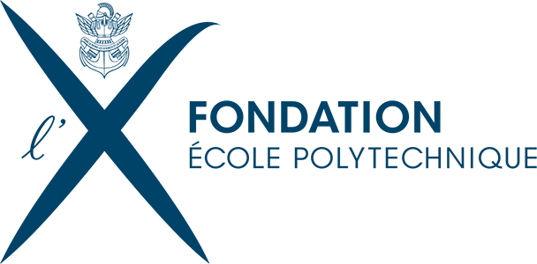

- Description

École Polytechnique, founding member of Institut Polytechnique de Paris (IP-Paris), invites applications for the Gaspard Monge Visiting Professor Program (GMVP), with the support of the École Polytechnique Foundation (FX).
The program welcomes leading international researchers to join École Polytechnique’s research center for 4 to 12 months to collaborate with one of its laboratories on strategic scientific topics.
Visiting professors contribute through research, teaching, and the organisation of scientific events, fostering long-term collaborations between École Polytechnique and their home institutions. Visiting professors may also be accompanied during their stay by a PhD student or a postdoctoral researcher.

Call for applications

- Guidelines

Duration of the stay

- The duration of the visit can be between 4 and 12 months. The stay can be divided into two separate visits of at least two months each, provided that they occur within an 18-month period. The visits (stays) must take place before the end of the two calendar years following the year of the call (i.e., the call in year N will fund visits in years N+1 and N+2).

Funding (up to €150,000 per year per project) may include:

- Monthly allowance for the visiting professor (suggested: €3,500 net/month)

- Round-trip airfare to/from France

- An apartment in Palaiseau, near the École Polytechnique campus, made available by the École Polytechnique Foundation (FX), which can also accommodate the visiting professor’s family (an information sheet with details of the apartment is available for download). The visiting professor will be exempt from paying rent. *If the visiting professor prefers to reside outside the apartment offered by the FX, a monthly rent reimbursement of up to €1,000 for a maximum period of six months may be provided.

- A budget to organize scientific events (workshops, seminars, conferences, etc.)

- Allowance for an accompanying PhD student or postdoc (€1500/month)

Eligibility

- Candidates must hold a permanent faculty position at an academic institution outside of France (not open to postdocs).

- The visiting professor must remain employed and paid by their home institution during the stay.

- The proposed research project must be connected to an École Polytechnique laboratory and align with the scientific priorities of École Polytechnique.

- Priority is given to senior researchers (PhD +10 years) recognized internationally in their field, though exceptional younger faculty (PhD +5 years) may also be considered.

Academic Activities

- Research: The visiting professor will pursue a collaborative research project and actively participate in the host laboratory’s academic life. Their visit may also provide an opportunity to initiate new research collaborations at École Polytechnique, either within existing scientific disciplines or through new interdisciplinary initiatives. It may further contribute to strengthening ties between the professor’s home institution and one or more laboratories at École Polytechnique.

- Teaching: The visiting professor will deliver a course or seminar on a topic of their choice, in agreement with the academic department to which they will be affiliated. This course or seminar will be integrated into one of École Polytechnique’s academic programs. A teaching load of 48 hours per 12-month period (approximately 4 hours per month) is expected. The visiting professor will also give an inaugural lecture.

- Scientific Events: organization of at least one scientific conference, workshop or seminar series with external speakers

3. Application

Applications must be submitted in English by the École Polytechnique host faculty member to: visitingprof.application@polytechnique.fr

Each application must include the following documents:

- Application form
- Curriculum Vitae
Include full academic background, key positions held, and a short commentary on five selected publications.
- Letter of Support from the Home Institution
Signed by the head of the department or relevant authority confirming the candidate’s employment and support for the visit.
- Letters of support from the Head of the hosting department and the head of the hosting research unit at Ecole Polytechnique.
The letter from the Head of the Hosting Department should confirm that the proposed teaching program is appropriate and feasible at Ecole Polytechnique, while the letter from the Head of the Hosting Research Unit should confirm that the unit has the necessary capacity to host the proposed research project (in terms of space, administrative support for the proposed event organization, and, if needed, research facilities).

Phase | Date
Call opens | October 19, 2026
Application deadline | December 18, 2026
Selection committee | January 18, 2027
Notification of results | February 1, 2027
4. Timeline

5. Evaluation
Applications will be reviewed by a multidisciplinary scientific committee, chaired by the Provost and the Vice-Provost for Research, in presence of a representative of the Fondation de l’Ecole Polytechnique.

Evaluation criteria:
- Scientific excellence and originality of the project
- Relevance to École Polytechnique and IP-Paris research activities.
- Quality of proposed teaching and event organisation
- Potential for sustainable collaboration
- Strength of institutional support

GMVP
Contacts :
Daniel CEDENO, International Development Manager (Direction des Relations Internationales)
Xoana TRONCOSO, PhD, Research Strategy & Policy Advisor (Direction de la Recherche)

Contact e-mail:
visitingprof.application@polytechnique.fr



Funded by the École Polytechnique Foundation as part of its campaign Servir la Science.

